**Quiet Waters 13th Annual Howl-O-Ween Barkin’ Bash**

**Saturday, October 25, 2014**

**11:00am – 3:00pm**

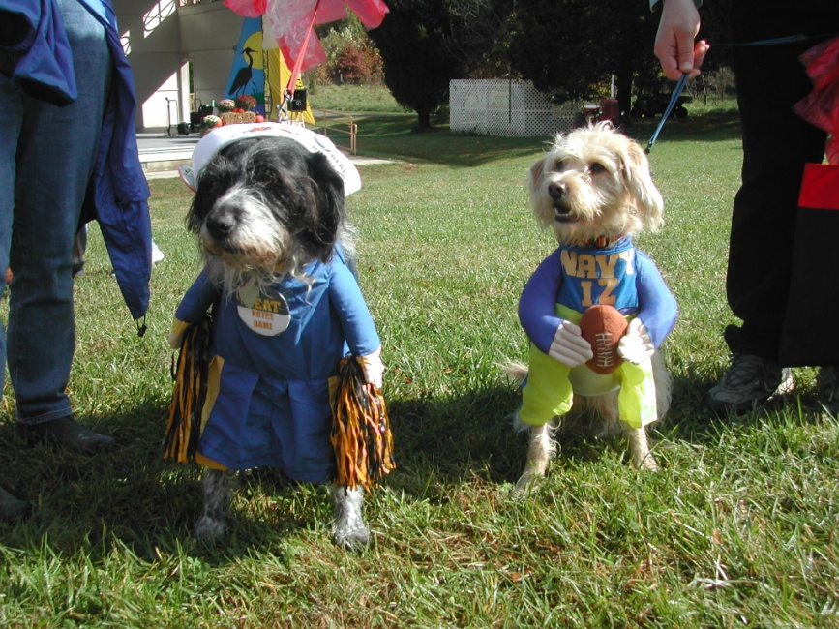

**Dress up your dog and join the fun at the 13th Annual Howl-O-Ween Barkin’ Bash. Contests, Games, Raffles, Dog Demonstrations, Food and Vendors!!**

**Costume Contests at 12:00pm; Most Annapolitan, Funniest, Most Creative, Best Owner/Dog Combo, Scariest, Cutest and Best in Show.**

**Contests/Games; Musical Chairs, Terrific Trick, Best Singer and Spooky Spoon Walk.**

**Tickets are $6 per dog for 3 Contests/Games. On-Site Registration the day of the event. Quiet Waters Park, 600 Quiet Waters Park Road, Annapolis, MD 21403.**

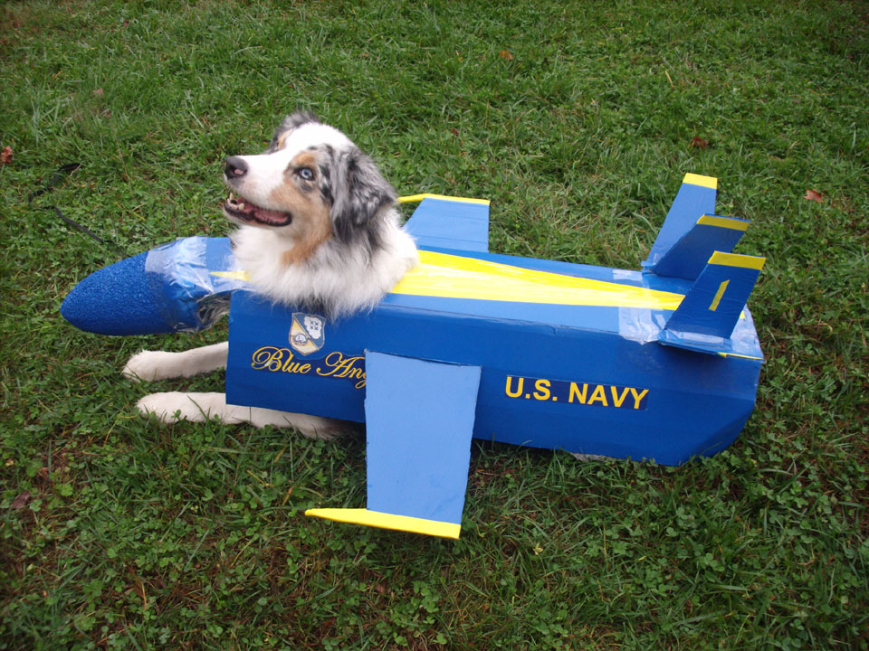

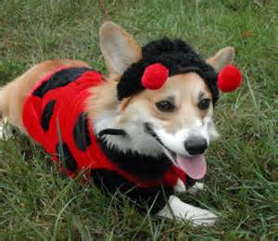

Park Entry is Free!

Prizes and Gifts!



**Volunteers, dog rescues and interested vendors should contact Park Ranger Winton at: rpwint39@aacounty.org**

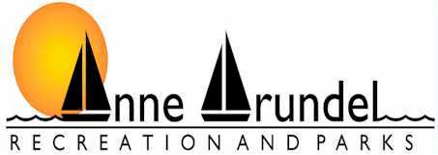

Friends of Quiet Waters Park

**Hosted by**